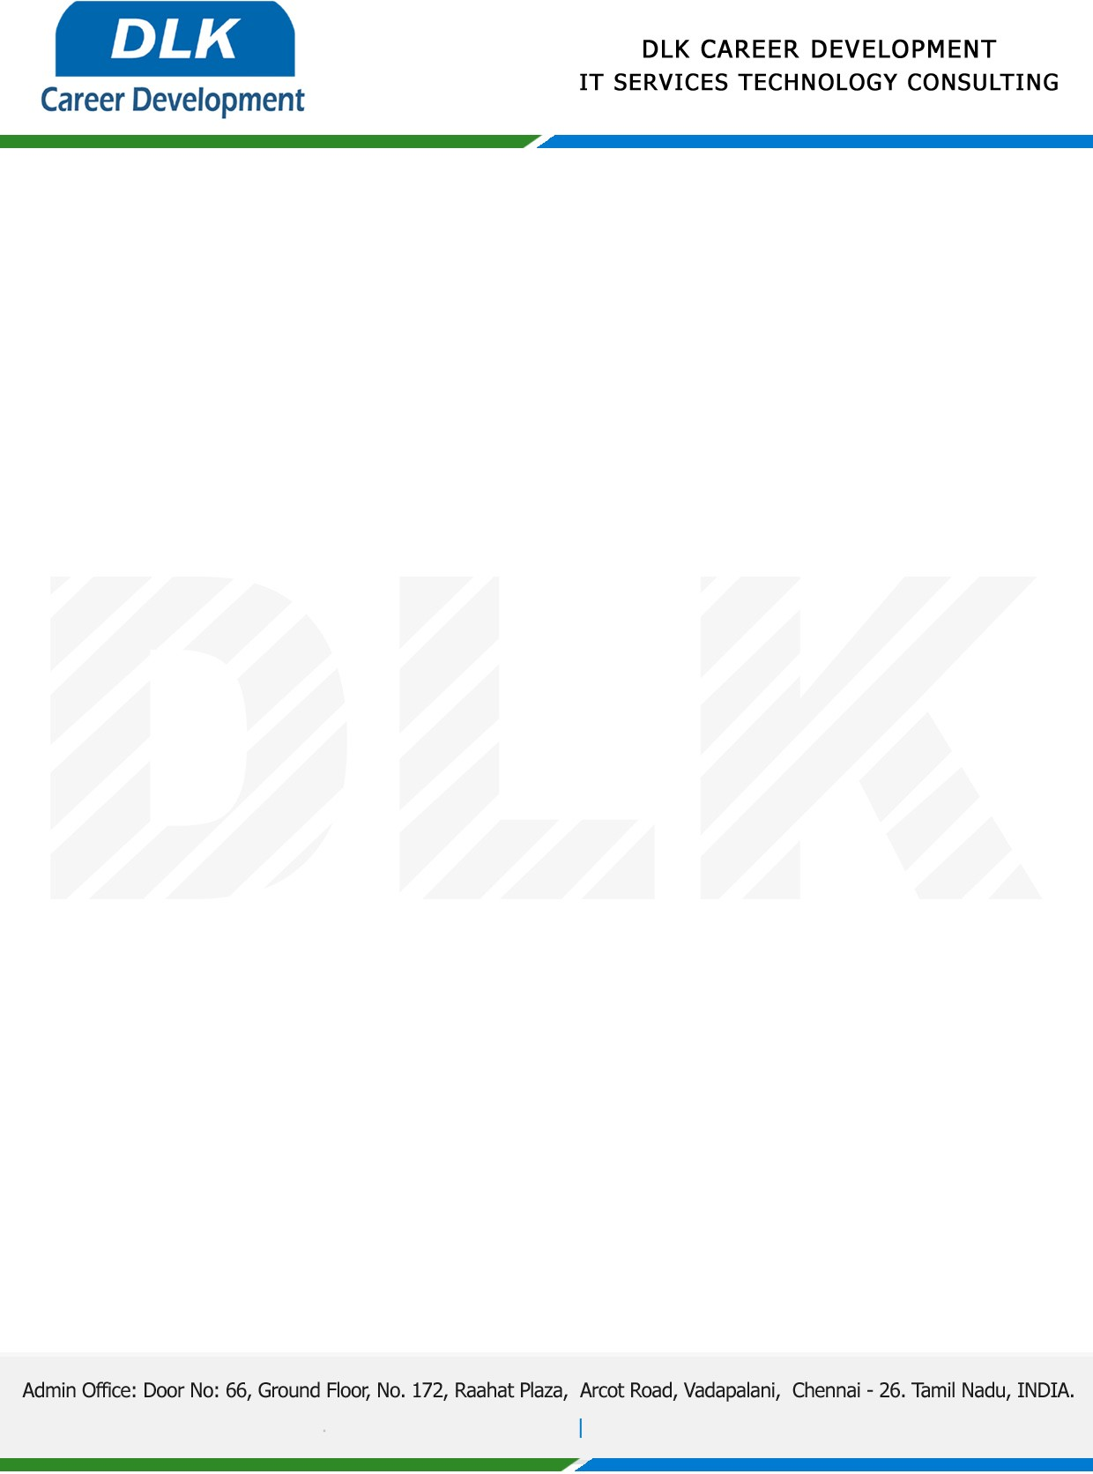

**Date: 12/May/ 2023**

**SUBJECT: INTERNSHIP COMPLETION CERTIFICATE**

This is to certify that **MR VIGNESH S (REG NO: S222120)** of **MCA (COMPUTER APPLICATION)** first year student at **DR.MGR EDUCATIONAL AND RESEARCH INSTITUTE UNIVERSITY, CHENNAI** has Successfully Completed the Internship under the domain of **“PYTHON PROGRAMMING“**in our organization during the Period **(3rd April 2023 to 5th May 2023).**

We appreciate your interest in **DLK CAREER DEVELOPMENT**

**“Best Wishes for Your Future Endeavors “**

For **DLK CAREER DEVELOPMENT**

